4.48:
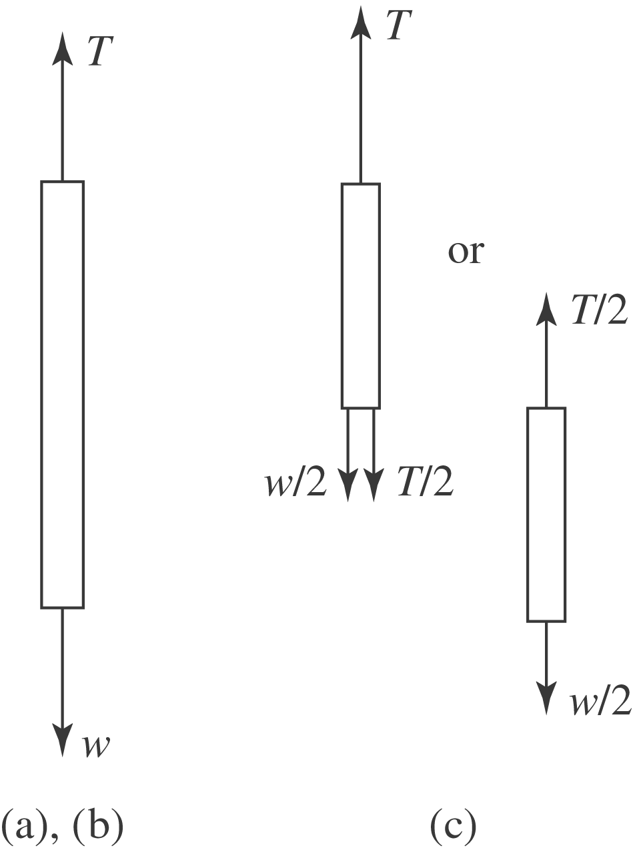
a) The net force on a point of the cable at the top is zero; the tension in the cable must be equal to the weight w.
b) The net force on the cable must be zero; the difference between the tensions at the top and bottom must be equal to the weight w, and with the result of part (a), there is no tension at the bottom.
c) The net force on the bottom half of the cable must be zero, and so the tension in the cable at the middle must be half the weight, 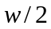. Equivalently, the net force on the upper half of the cable must be zero. From part (a) the tension at the top is w, the weight of the top half is and so the tension in the cable at the middle must be 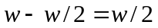.
d) A graph of T vs. distance will be a negatively sloped line.

